### Delete a list of keys from a dictionary

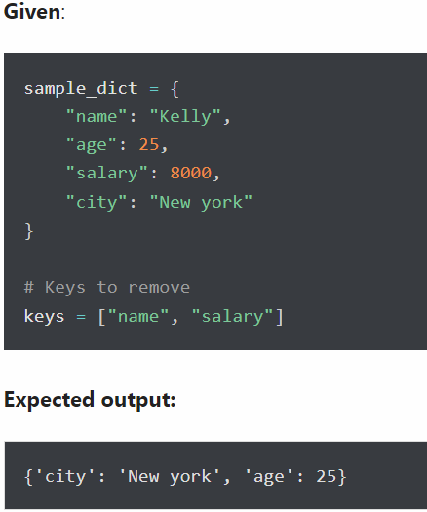

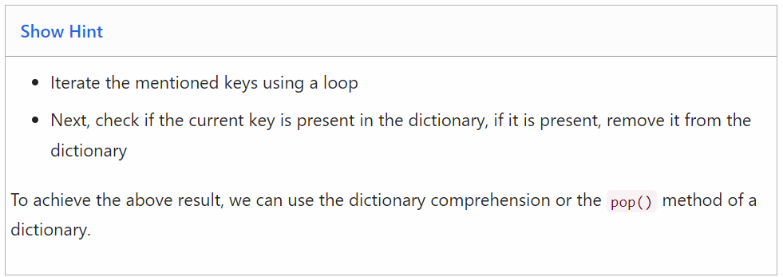

sample_dict.pop('name')

sample_dict.pop('salary')

print(sample_dict)

{'age': 25, 'city': 'new york'}

### Check if a value exists in a dictionary

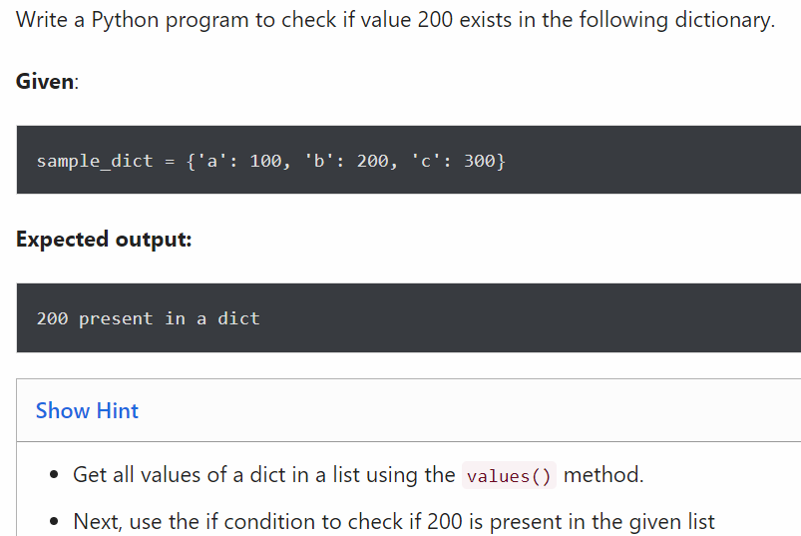

if 200 in sample_dict.values():

print('200 present in a dict')

200 present in a dict

### Rename key of a dictionary

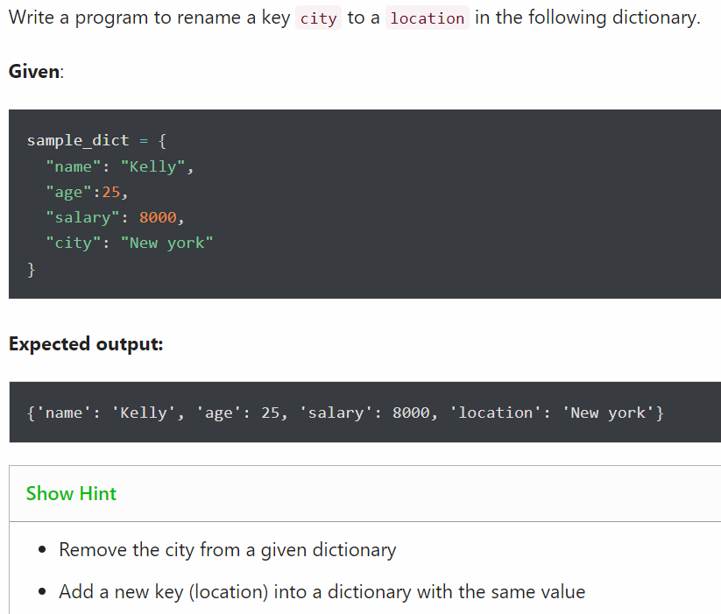

sample_dict.pop("city")

print(sample_dict)

sample_dict["location"]="new york"

print(sample_dict)

{'name': 'kelly', 'age': 25, 'salary': 8000}

{'name': 'kelly', 'age': 25, 'salary': 8000, 'location': 'new york'}

### Get the key of a minimum value from the following dictionary

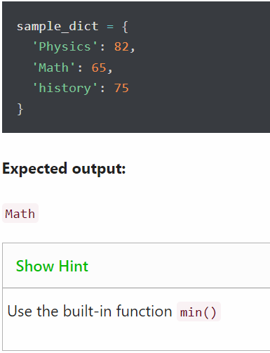

x=min(85,65,75)

print(x)

65

### Change value of a key in a nested dictionary

Write a Python program to change Brad’s salary to 8500 in the following dictionary.

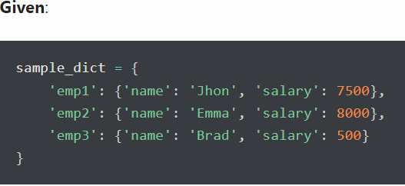

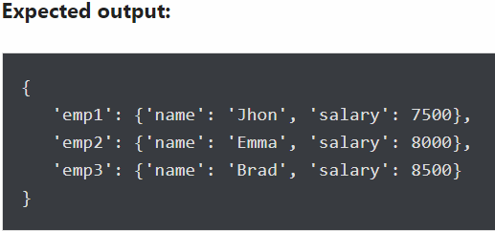

sample_dict['emp3']['salary'] = 8500

print(sample_dict)

{'emp1': {'name': 'john', 'salary': 7500}, 'emp2': {'name': 'emma', 'salary': 8000}, 'emp3': {'name': 'brad', 'salary': 8500}}



namedictionary={"firstname":"liset","lastname":"mathew"}

print(namedictionary)

{'firstname': 'liset', 'lastname': 'mathew'}